Software Requirements Specification
Final Project: Wandering in the Woods

Subject: Software Engineering
Professor Fadi Wedyan
Submitted by: Likhita Killari
Lewis University

March 14, 2026

Github link:
Table of Contents
1.0 Introduction 3
1.1 Purpose 3
1.2 The Wandering in the Woods Simulation 3
2.0 Process Model 5
3.0 Use Cases 6
3.1 Use Case 1: Run K-2 Simulation 6
3.2 Use Case 2: Run Grades 3-5 Simulation (Small Data & Grouping) 7
3.3 Use Case 3: Run Grades 6-8 Simulation (Big Data & Algorithms) 8
3.4 Use Case 4: Run User Play Mode (Manual Control) 9
4.0 UML Model 10
4.1 Use Case Diagram 10
4.2 Deployment Diagram 12
4.3 Class Diagram 14
4.4 State Diagram 17
4.5 Activity Diagram 19
5.0 Customer Journey Map 22
6.0 Personas 23
Persona 1: The Student Learner (Leo, 4th Grade) 23
Persona 2: The Educator (Ms. Davis, Middle School STEM Teacher) 24
7.0 UI Mock-up 24
8.0 Testing Strategy 26
8.1 Unit Testing 27
8.2 Integration Testing 28
8.3 Usability Testing 28
8.4 Validation Testing 29

1.0 Introduction

1.1 Purpose
This document describes the software design and requirements of the "Wandering in the Woods" educational computer simulation. This documentation is provided to outline the processes, functional requirements, and architectural design necessary to develop, maintain, and understand the application.
We developed this documentation following an agile philosophy, focusing on the minimal yet comprehensive descriptive information required to ensure the software development team, the professor, and other stakeholders (such as teachers and students) have a thorough understanding of the software to be built. Further following Agile principles, this document serves as an iteration of the final design and remains a work in progress that can be updated as new features are added. This document will be highly useful for developers maintaining the codebase, instructors evaluating the project's algorithmic complexity, and educators utilizing the simulation in a classroom setting.

1.2 The Wandering in the Woods Simulation
"Wandering in the Woods" is an interactive 2D computer simulation that functions as an educational game. It is expressly designed to help K-8 students learn about computation, computational thinking, mathematical concepts, algorithmic efficiency, and computer science. The simulation is designed to be utilized by a pair of students working collaboratively in front of the same screen and features dynamic Text-to-Speech (TTS) audio directions and sound effects to guide the users.
The core premise of the simulation revolves around "lost people" represented as avatars on a customizable rectangular grid (the woods). Because the woods are dense, the avatars cannot see or hear each other until they land on the exact same cell in the grid. To ensure a shortened learning curve as students progress through their school years, the application maintains a consistent look and feel across four distinct modes of increasing complexity:
- Grades K-2 Mode: A visually simple, automated version designed to introduce the basic concept. The grid is strictly square, and two players start in diagonally opposite corners. They wander randomly, and the system counts each step until they meet, ending with a happy audio-visual celebration.
- Grades 3-5 Mode: Introduces "Small Data" and user configuration. Students can define the grid dimensions (rectangular) and the number of players (2, 3, or 4), and manually place them anywhere on the grid. This mode introduces a "grouping" mechanic: if two players find each other, they merge and move together as a single unit until all players are found. The system displays ongoing session statistics, including the shortest run, longest run, and average run.
- Grades 6-8 Mode: Introduces "Big Data" and algorithm exploration. Students have all the controls from the 3-5 tier but are challenged to run automated bulk experiments (e.g., simulating 50 runs instantly). The system dynamically generates and displays histogram graphs of the data distribution. Furthermore, students can toggle between different wandering protocols (a purely "Random" search vs. a "Smart" centralized search) to judge which algorithm is the most efficient way to meet up.
- User Play Mode: A bonus interactive mode that allows two students to manually control their avatars using keyboard inputs (Arrow keys for Player 1; U, D, L, R for Player 2), allowing them to test human pathfinding against the computer's algorithms.

2.0 Process Model
The software development team utilized an Evolutionary Agile Process Model to develop the "Wandering in the Woods" simulation. The model selected by the team is based on the necessity for rapid prototyping, continuous iteration of design, and the need to prioritize end-user (K-8 students) usability and robustness.
Because the application is targeted at children who interact with software interfaces and keyboards in unpredictable ways a rigid, traditional waterfall approach was deemed inappropriate. Instead, the model incorporates Agile and Spiral model principles to encapsulate immediate feedback, risk management, and continuous evolution of the game's architecture.
The development was broken down into incremental deliverables based on the grade-level requirements:
- First Prototype (Core Mechanics): Development of the fundamental grid mathematics, 2D rendering pipeline (Pygame), and the foundational "Pure Random Walk" algorithm for the K-2 mode.
- Second Iteration (Small Data & Grouping): Expanding the architecture to handle dynamic grid resizing, multiple players, the object-merging grouping mechanics for the 3-5 mode, and session-level statistical tracking.
- Third Iteration (Big Data & Threading): Integrating complex components such as Matplotlib for headless graph generation, multi-threading to prevent UI blocking, and "Smart" wandering protocols for the 6-8 mode.
- Final Polish (UX & Usability): Integrating the Text-to-Speech (TTS) engine, global statistics, custom user play modes, child-proofing the keyboard inputs, and finalizing the graphical and audio assets.
By evaluating the prototype at each of these stages, the team was able to confidently add complex layers (like threaded data simulation) without breaking the core K-2 wandering logic.

3.0 Use Cases
The following use cases were defined by the development team and the project requirements as the core system functionalities for the delivery of the "Wandering in the Woods" simulation. Each use case encapsulates a specific interaction a student or teacher will have with the system across the different grade-level modules. Each use case lists the primary actor, preconditions, description, and acceptance criteria.

3.1 Use Case 1: Run K-2 Simulation
Primary Actor: K-2 Student / User
Preconditions: The application is launched, the Welcome Screen has been bypassed, and the Main Menu is currently displayed.
Description: As a K-2 student, I want to be able to start a basic simulation where two characters wander in the woods so that I can easily observe the concept of random paths intersecting.
- I should be able to initiate the simulation with a single button click ("Grades K-2") without needing to configure any settings.
- I should hear an audio prompt welcoming me to the game.
- I want to watch two avatars automatically move step-by-step across an 8x8 grid.
- When the two avatars land on the exact same square, the simulation should stop, play a celebration sound, and use a voice assistant to announce exactly how many steps it took for them to meet.
Acceptance Criteria: I can start the K-2 simulation and watch two characters successfully execute a random walk algorithm until they collide. The system correctly tracks the steps, prevents the avatars from walking off the grid, and delivers the correct audio-visual feedback upon completion.

3.2 Use Case 2: Run Grades 3-5 Simulation (Small Data & Grouping)
Primary Actor: Grades 3-5 Student / User
Preconditions: The application is launched, the Welcome Screen has been bypassed, and the user has clicked "Grades 3-5" on the Main Menu, entering the Setup Phase.
Description: As a 3rd to 5th-grade student, I want to be able to configure the environment and manually place my characters so I can explore variables and observe "Small Data" statistics.
- I should be able to use "+" and "-" buttons to change the number of Columns (from 5 to 15), Rows (from 5 to 12), and the number of Players (from 2 to 4).
- I should be able to manually click on the grid to place the selected number of players exactly where I want them to start.
- Once the last player is placed, the simulation should start automatically.
- During the simulation, when two characters collide, they should group together (indicated by a red number showing group size) and continue wandering as a single unit until all players are grouped.
- When the simulation finishes, the system should update the "Mode Stats" panel to show my shortest run, longest run, and average run for the session.
Acceptance Criteria: The user can successfully adjust the grid dimensions and player count within the defined boundaries. The grid visually scales to match the selected dimensions. Mouse clicks accurately map to grid coordinates to spawn players. The grouping algorithm successfully merges colliding entities, and the small data statistical dashboard correctly calculates and displays the minimum, maximum, and average steps of the session.
Open Issue: Need to address the edge case where a user attempts to click and place a new player on the exact same grid coordinate as an already placed player during the setup phase.

3.3 Use Case 3: Run Grades 6-8 Simulation (Big Data & Algorithms)
Primary Actor: Grades 6-8 Student / User
Preconditions: The application is launched, the Welcome Screen has been bypassed, and the user has clicked "Grades 6-8" on the Main Menu, completing the grid and player setup phase.
Description: As a 6th to 8th-grade student, I want to be able to toggle between different wandering algorithms and generate "Big Data" sets so that I can analyze mathematical efficiency and data distribution.
- I should have all the configuration and manual placement abilities from the Grades 3-5 mode.
- I should be able to click a toggle button to switch the active wandering algorithm between "Random" (pure random walk) and "Smart" (a heuristic algorithm where players tend to move toward the center of the grid).
- I should be able to click a "Run Big Data" button to instantly run the current grid configuration 50 times in the background.
- While the data is generating, the UI should not freeze; it should display a "Generating Big Data... (Please wait...)" message.
- Once the 50 runs are complete, a histogram graph should automatically render on the screen showing the distribution of steps taken across all 50 simulations.
Acceptance Criteria: The user can successfully toggle the algorithm mode and trigger the Big Data simulation. The system successfully utilizes background threading to execute 50 headless runs without blocking or freezing the main Pygame user interface. Upon completion, the system successfully translates the Matplotlib histogram into a Pygame-readable image and displays it accurately on the screen.

3.4 Use Case 4: Run User Play Mode (Manual Control)
Primary Actor: Student / User
Preconditions: The application is launched, the Welcome Screen has been bypassed, and the user has clicked "User Play Mode" on the Main Menu, completing the grid configuration and placing exactly two players.
Description: As a student, I want to be able to manually control my avatar alongside a partner so that we can test our own pathfinding skills against the computer's automated algorithms.
- I should be able to control Player 1's movements using the Up, Down, Left, and Right Arrow keys on the keyboard.
- My partner should be able to simultaneously control Player 2's movements using the "U", "D", "L", and "R" keys.
- The system should prevent us from moving outside the boundaries of the grid.
- The system should track the total number of combined steps we take.
- When our avatars land on the exact same grid coordinate, the simulation should stop, play the celebration audio, and congratulate us on finding each other.
- Our manual run data should be saved to the "User Play" global statistics category.
Acceptance Criteria: The application successfully maps the specified keyboard inputs to the correct player objects and updates their coordinates accordingly. Boundary logic prevents avatars from walking off the screen. Collision detection successfully registers when the user-controlled players intersect, halts movement, triggers the Text-to-Speech audio, and logs the final step count to the global statistics dictionary.

4.0 UML Model

4.1 Use Case Diagram
The Use Case diagram visualizes the primary interactions between the users (students/teachers) and the "Wandering in the Woods" system. It illustrates the core functionalities available to the user and how certain behaviors (like setting up the grid or running big data) relate to the main simulation modes.
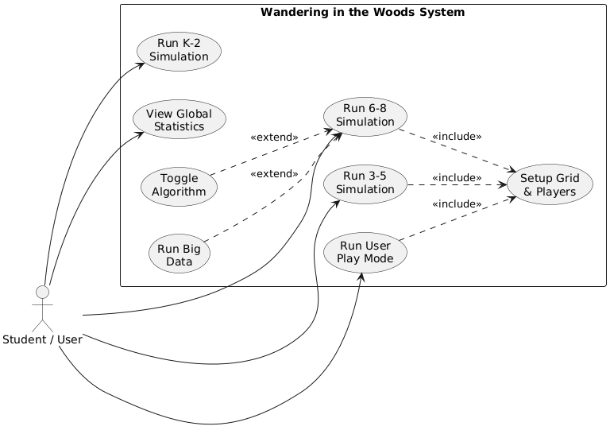
Figure 2. Use Case Diagram for the Wandering in the Woods System.
The Use Case Diagram for the "Wandering in the Woods" system features a single primary actor: the Student / User. This actor interacts with the system to perform five main actions, represented by the primary use case ovals: running the K-2, 3-5, and 6-8 simulations, playing the User Play Mode, and viewing the Global Statistics dashboard.
To accurately model the system's architecture, we use <<include>> and <<extend>> relationships:
- <<include>> Relationship: The Run 3-5, Run 6-8, and Run User Play use cases all point to the Setup Grid & Players use case with an <<include>> relationship. This means that configuring the grid dimensions and manually placing players is a mandatory, integrated step before any of these three simulations can actually begin. (Notice that K-2 does not include this, as it is fully automated).
- <<extend>> Relationship: The Run Big Data and Toggle Algorithm use cases point to the Run 6-8 Simulation with an <<extend>> relationship. This indicates that these are optional, specialized features that expand the core functionality of the 6-8 mode, allowing older students to trigger background threading and heuristic pathfinding.

4.2 Deployment Diagram
The Deployment Diagram illustrates the physical architecture and hardware-software relationships required to run the "Wandering in the Woods" system. Because this is a lightweight, accessible educational tool, it is designed to run locally on standard hardware without needing cloud servers or internet connectivity.
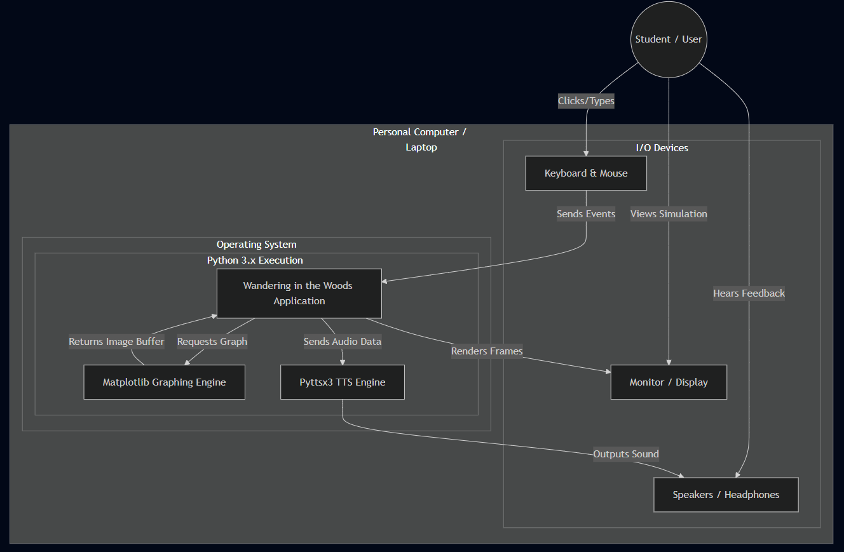
Figure 3. Deployment diagram for the Wandering in the Woods System.
A deployment of the "Wandering in the Woods" system is illustrated in the Deployment Diagram. The system software is built as a standalone desktop application that runs on a central processor, which we view as running on a standard classroom computer or student's personal laptop.
The user interfaces with the system through standard Input/Output (I/O) peripherals. The user looks at the Monitor/Display to view the 2D Pygame augmented grid, listens to the Speakers/Headphones to hear the Text-to-Speech instructions and sound effects, and uses the Keyboard and Mouse to configure grids, place avatars, and manually control characters in User Play Mode.
Internally, the hardware Operating System hosts a Python 3.x Execution Environment. The core "Wandering in the Woods Application" acts as the central software node, receiving input events from the keyboard/mouse. When complex tasks are required, the core application delegates them to specialized local engines: it sends raw data arrays to the Matplotlib Graphing Engine to generate "Big Data" histograms, and it sends text strings to the Pyttsx3 TTS Engine to generate audio feedback. All software components are contained locally, meaning the application is highly secure for children and requires no active wireless or internet connection.

4.3 Class Diagram
The class diagram for the core system of the "Wandering in the Woods" simulation is depicted below. It illustrates the object-oriented structure of the Python codebase, showing the data attributes and methods for each major component, as well as the inheritance and compositional relationships between the UI, Logic, and Application layers.
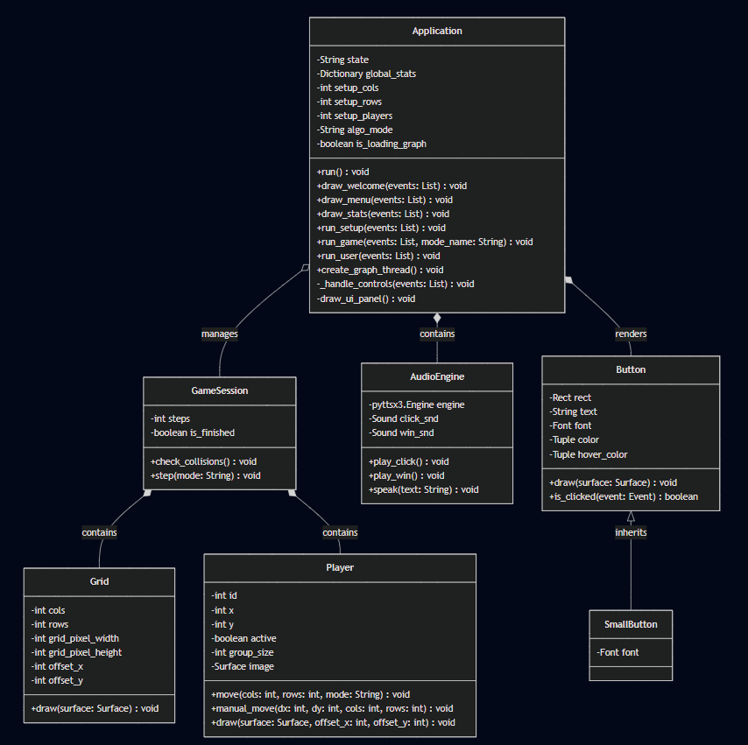
Figure 4. Class diagram for the Wandering in the Woods System.
The core software architecture of "Wandering in the Woods" relies on a modular, Object-Oriented design. The classes in the diagram interact as follows:
- Application: The central controller class that runs the Pygame window loop. It maintains the global state of the program (such as whether the user is on the Welcome screen, Main Menu, or playing a specific grade-level mode) and holds the global_stats dictionary across multiple sessions. It aggregates the active GameSession and handles threaded requests like create_graph_thread().
- AudioEngine: A dedicated utility class instantiated by the Application. It encapsulates the pyttsx3 text-to-speech engine running on a daemon thread (to prevent UI blocking) and handles the initialization and playback of Pygame mixer sound effects (click sounds, background music, and win sounds).
- GameSession: Represents a single, active simulation round. It tracks the current number of steps and a boolean is_finished flag. It acts as a container that brings together exactly one Grid and a list of Player objects. It holds the core logic method check_collisions() which determines if players have occupied the same coordinates.
- Grid: A purely mathematical and visual class that tracks the dimensional boundaries (cols, rows) of the current simulation. It dynamically calculates its offset_x and offset_y so that the grid (and the background image) scales and centers perfectly within the Application window.
- Player: Represents the avatars wandering in the woods. Each player tracks its own coordinate (x, y), its active state, and its group_size (used when players merge). The move() method contains the logic for algorithmic wandering (Random vs. Smart), while the manual_move() method handles specific keyboard translations for the User Play Mode.
- Button: A reusable UI component that handles its own collision detection (is_clicked) and rendering (draw). It supports dynamic state changes, swapping between color and hover_color when the user's mouse intersects its bounding Rect.
- SmallButton: A subclass that directly inherits from Button. It overrides the font size attribute to render smaller interface elements, specifically used for the "+" and "-" configuration buttons during the Setup phase.

4.4 State Diagram
The state diagram in the figure below shows the high-level behavioral flow of the "Wandering in the Woods" application. It illustrates the major states of operation the system enters during normal use and the user actions that trigger transitions between these states.
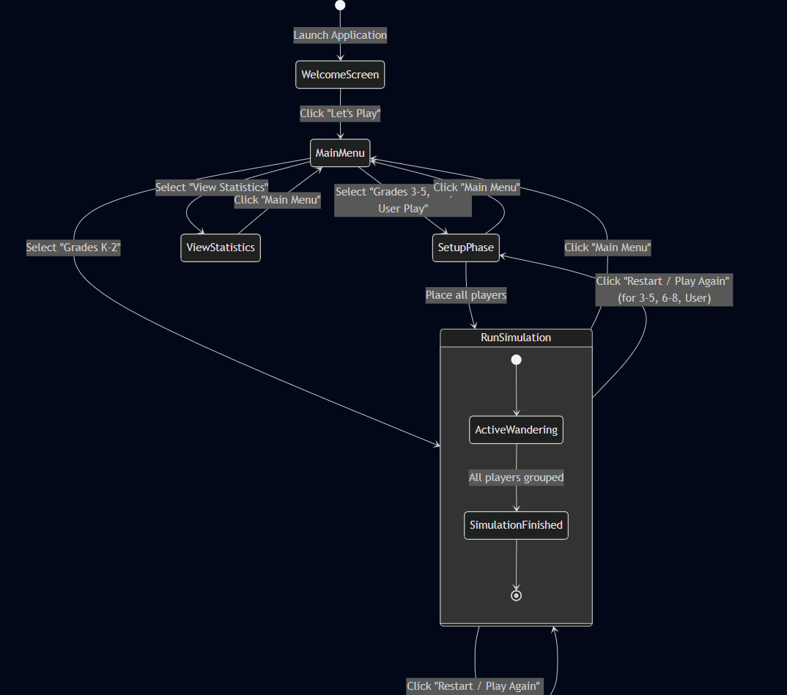
Figure 5. State diagram for the Wandering in the Woods System.
The system starts in the initial Welcome Screen state upon launching the application, displaying a personalized greeting. Clicking the start button transitions the system into the central Main Menu state. From the Main Menu, the system branches into three primary operational states based on the user's selection:
- View Statistics State: If the user selects to view global statistics, the system displays historical session data. The user can easily transition back to the Main Menu.
- Setup Phase State: If the user selects Grades 3-5, Grades 6-8, or User Play Mode, they transition into the Setup Phase. Here, the system waits for the user to configure grid dimensions and place the required number of players on the board. Once the final player is placed, the system automatically transitions into the Run Simulation state.
- Run Simulation State: If the user selects Grades K-2, they bypass the Setup Phase and transition directly into this state. The Run Simulation state is a composite state where the active simulation occurs (ActiveWandering). Once the collision algorithm detects that all active avatars have merged, the internal state shifts to SimulationFinished, which triggers the Text-to-Speech audio and visual feedback.
From the Run Simulation state, the user can transition back to the Main Menu at any time, or they can choose to restart the game, which loops them back to the Setup Phase (or immediately restarts the run for the automated K-2 mode).

4.5 Activity Diagram
The activity diagram shown below presents a detailed view of the runtime execution flow and low-level behavior of the "Wandering in the Woods" core application loop. It outlines the step-by-step processes the software executes from launch to the completion of a simulation.
(Note zoom in the document to view the Activity diagram in next page.)
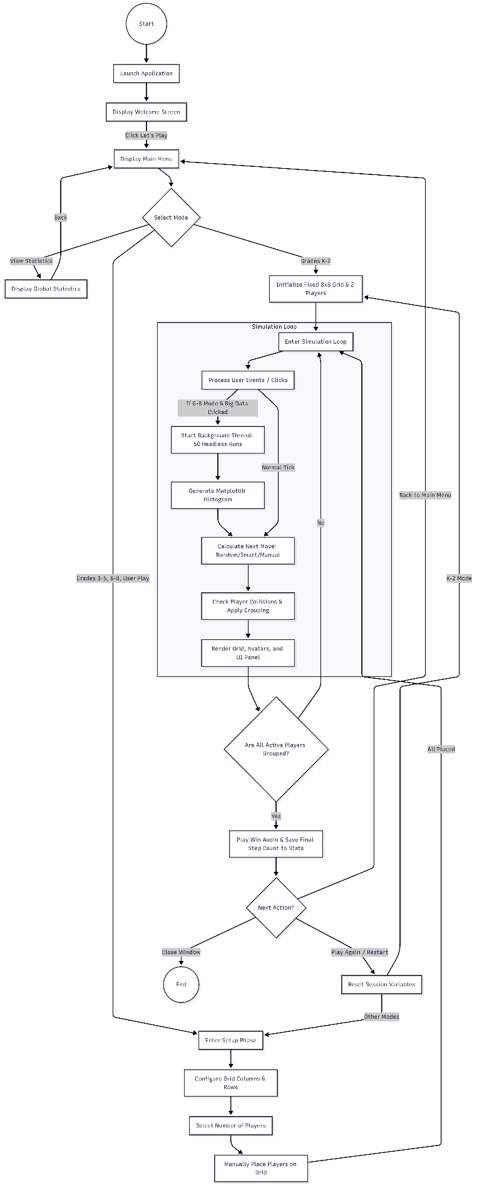
Figure 6. Wandering in the Woods high-level activity diagram.
Following a similar logical progression as the state diagram, the Activity Diagram breaks down the "Wandering in the Woods" program into its functional execution paths.
When the application launches, it loads the assets and opens the Welcome Screen. Upon clicking "Let's Play," the system enters the Main Menu, where the flow diverges based on the user's selected mode:
- View Statistics: A simple path that loads the global dictionary of past game data, displays it, and loops back to the menu.
- Grades K-2 Mode: The system automatically initializes a fixed 8x8 grid with 2 players at the corners and immediately drops into the simulation loop.
- Other Modes (3-5, 6-8, User Play): The system enters the Setup Phase, which requires sequential user input. The system waits for the user to configure the columns, rows, and player count, and then waits for physical mouse clicks to place the avatars. Only when all avatars are placed does the system enter the simulation loop.
The Simulation Loop is the core Pygame loop executing at a set frame rate (FPS). During each tick:
- The system first checks for user events (like keyboard inputs or button clicks).
- Concurrency Fork: If the user is in Grades 6-8 and clicks "Run Big Data", the system forks a background thread to calculate 50 headless simulations and generate a Matplotlib graph without interrupting the visual simulation frame rate.
- The system then calculates the next move for all active players based on the selected algorithmic protocol (Random, Smart, or Manual keyboard inputs).
- It then calculates collisions. If two players share a coordinate, they are grouped.
- Finally, the system renders the updated graphics to the display.
At the end of the loop, the system evaluates a decision node: Are all players grouped? If not, the loop runs again. If they are, the system plays the victory audio, logs the steps to the global statistics, and waits for the user to either play again, return to the main menu, or quit the application entirely.

5.0 Customer Journey Map
A detailed customer journey map for the "Wandering in the Woods" system was created by the development team in order to better understand the user experience of our primary customers: K-8 students and their educators.
The primary goal of the customer is to easily set up and execute a computational simulation to observe and analyze mathematical algorithms and data sets without being overwhelmed by technical interfaces. The waypoints in the map clarify the likely steps of the user as they attempt to accomplish their educational goals, from initially launching the application to analyzing the final statistical outputs.
Often, users especially younger students may experience roadblocks or setbacks on the path to their goal, such as confusion during grid configuration or mis clicking outside of the interactive zones. These should be modeled as part of the customer journey map. To mitigate this, the design team restricted text inputs and utilized highly visual "+ / -" buttons and direct mouse-click placements, making the user process relatively straightforward. It is important to keep in mind that further usability testing in a live classroom environment may uncover hidden perils for the students, which would be important to update here in this living document.
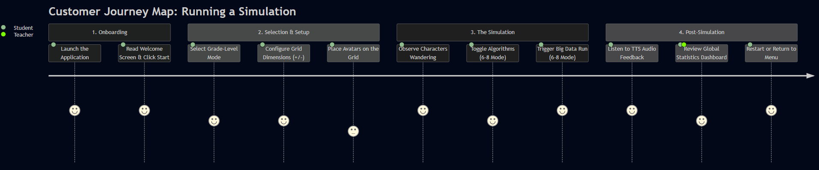
Figure 7. Customer journey map for the Wandering in the Woods system.

6.0 Personas
A representative sample of personas for the "Wandering in the Woods" system is detailed below. Because this educational software targets a wide age range (Grades K-8) as well as the educators facilitating the lessons, it is critical to have a diverse collection of personas with which to evaluate the project. Here, the development team has provided two primary personas representing our core end-users.
Although the specific names and images of the personas are not the most important aspect, the accompanying information builds potential customer profiles that the development team must take into consideration when analyzing and upgrading the project.

Persona 1: The Student Learner (Leo, 4th Grade)
- Profile: Leo is 9 years old and is being introduced to basic computer science and variables in his math and science classes. He is highly visual, enjoys interactive games, but gets easily frustrated if a user interface requires too much typing or reading long instructions.
- Impact on Design: When evaluating the system for Leo, the development team recognized the need to minimize keyboard input for the setup phase. This led to the design of the highly visual "+" and "-" buttons for grid configuration, and the intuitive "click-to-place" mechanic for spawning avatars. Furthermore, to keep Leo engaged, the team integrated the Pyttsx3 Text-to-Speech engine to provide auditory feedback and celebration sounds rather than relying solely on pop-up text boxes.

Persona 2: The Educator (Ms. Davis, Middle School STEM Teacher)
- Profile: Ms. Davis teaches 6th to 8th-grade computer science. She needs software that runs easily on older school-provided laptops without requiring complex installations, internet access, or cloud accounts. She wants tools that allow her students to quickly generate data so they can spend more class time analyzing results rather than setting up the experiment.
- Impact on Design: Ms. Davis's needs drove the development of the "Big Data" headless simulation feature. By utilizing Python threading, the system can instantly generate 50 runs and automatically display a Matplotlib histogram, fulfilling her need for rapid data generation. Additionally, her requirement for simple, offline access drove the architectural decision to build the simulation as a self-contained Pygame executable that does not rely on web servers or internet connectivity.

7.0 UI Mock-up
The user interface for the "Wandering in the Woods" simulation was designed with accessibility and clarity in mind, particularly for younger students. An initial UI mock-up and layout description of the active simulation is presented below.
The screen is divided into two primary functional areas:
- The Simulation Canvas (Left/Center): This area displays the dynamically scaling 2D grid overlaying the "woods" background image. The avatars (players) are rendered within these grid cells and move step-by-step. The grid automatically centers itself to ensure the visual focus remains on the wandering algorithms.
- The Control Panel (Right): A solid-colored UI panel occupies the right side of the screen. This panel provides real-time data and interactive controls.
  - The top of the panel displays the current Mode (e.g., "6-8" or "K-2") and a Live Steps counter that updates dynamically as the avatars move.
  - The middle of the panel contains the Mode Stats dashboard, which persistently tracks the Shortest Run, Longest Run, and Average Run across the session.
  - The bottom of the panel houses the interactive Buttons, such as "Restart Round", "Play Again!", "Main Menu", and specific algorithmic toggles (like "Run Big Data" or "Algo: Random") depending on the active grade-level mode.
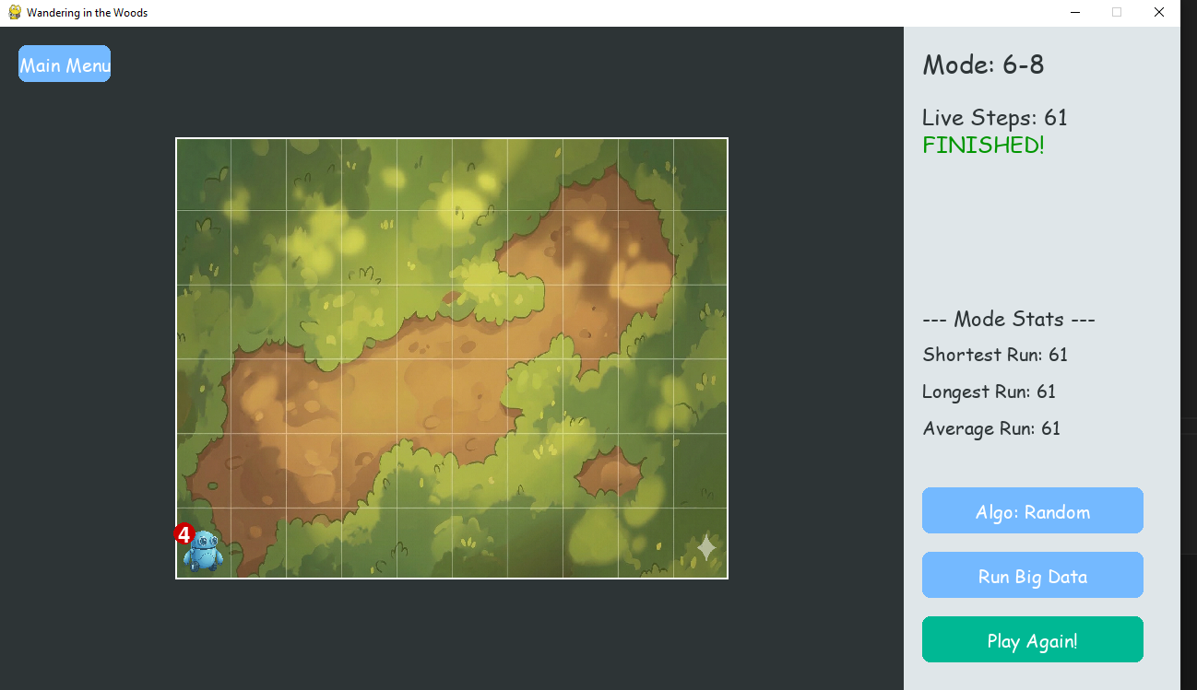
Figure 8. User interface layout for the Wandering in the Woods system.

8.0 Testing Strategy
It is important to define our test strategy in order to accurately create our test cases, manage the project timeline, and ensure testing is performed by critical deadlines. A well-crafted test strategy complements the evolutionary agile software development lifecycle model the team has selected.
The test strategy describes the approach to testing the software team will use to ensure the educational simulation delivered meets the requirements and quality standards set by the stakeholders (the professor, educators, and students). Because the software is intended for use by children, the testing must heavily emphasize edge cases involving unpredictable user inputs. The development team has selected four categories of test cases as part of their test strategy: unit testing, integration testing, usability testing, and validation testing.

8.1 Unit Testing
With unit testing, we will test the individual methods which are the smallest testable parts of the program. The methods will be tested as they are created to validate the system as it is developed. In our object-oriented Python architecture, the class is seen as the smallest unit, yet the smallest testable part remains the methods of the classes (such as the methods in logic.py).
Therefore, our unit tests focus on isolating the methods within our core logic classes: Player, Grid, and GameSession. Because this is an object-oriented Pygame application, it can be difficult to test a single operation in isolation without rendering the screen, resulting in the need to test sequences of mathematical methods independent of the UI layer.
A good test case for a unit test has a number and name to identify it, as well as a brief description of the test. The expected and actual output are noted. If the actual output matches the expected output, the test status is marked passed. Alternatively, if they do not match, the test is marked failed and indicates a potential bug.
For this type of unit testing, the developers will take each method defined in the Class Diagram (Figure 4) and create white-box test cases to verify the correct execution of the logic paths.
Example Unit Test Cases (from logic.py):
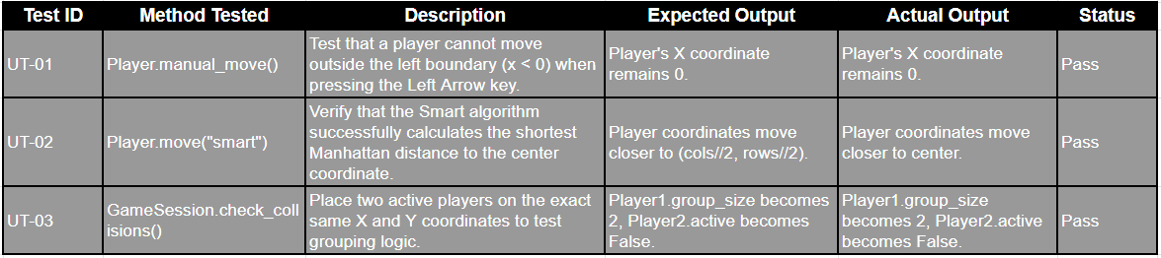

8.2 Integration Testing
Integration testing ensures that the individual methods and classes work correctly with each other and that all external library calls (such as Pygame, Pyttsx3, and Matplotlib) function as expected when combined. It is functionally improbable for a developer to successfully test the entire simulation loop at once without first verifying the interconnections between the various software components.
Therefore, integration testing must be performed incrementally so that small elements of the project are added together slowly, making it easier to isolate issues. For the "Wandering in the Woods" project, the team adopted a continuous integration approach, merging and testing components as they were built to align with the evolutionary process model.
Integration testing is performed by considering each use case one at a time and ensuring the classes needed to accomplish a use case interact correctly. For example, testing the Run Big Data use case requires verifying the integration between the Application class (which handles the UI), the run_headless_simulation() function (which handles the logic), and the Python threading library. A critical integration test involved verifying that executing 50 automated runs in the background thread did not block or crash the main Pygame rendering thread. As each use case was integrated into the prototype, regression testing was performed to ensure new errors were not introduced into the previously working K-2 logic.

8.3 Usability Testing
Usability is a type of high-order testing. For usability testing, the development team evaluates the degree to which users can effectively interact with the program through its visual interfaces. Because the target demographic for "Wandering in the Woods" includes children as young as Kindergarten, usability testing is critical to the project's success.
As part of usability testing, the team utilizes the personas developed in Section 6.0 (e.g., Leo the 4th Grader and Ms. Davis the Educator) to determine scenario-based tests for how representative users will interact with the software. The team conducts a cognitive walkthrough of the use cases from the perspective of these personas.
For example, a developer pretending to be Leo will attempt to navigate the setup phase for the Grades 3-5 mode. The developer will talk aloud as they try to complete the use case, specifically testing whether the "+" and "-" buttons are intuitive and if clicking on the grid to place avatars feels natural. The other developers watch for places where "Leo" gets stuck such as trying to place a player off the grid or clicking the same spot twice. These "pinch points" represent places where the interface or input validation needs to be improved to prevent frustration.

8.4 Validation Testing
Validation testing is performed after integration testing has passed and a prototype is ready for release. This testing occurs during the review of the project with the primary stakeholder (the professor) to ensure all functional, non-functional, and academic behavioral requirements have been fully satisfied.
This demonstration of function by the team should be directly guided by the customer journey map shown in Figure 7.
In usability testing, the developers are looking for places where the users fail to accomplish their goals. In validation testing, the developers are seeking to actively demonstrate that the implemented system delivers the exact functionality requested. For "Wandering in the Woods," successful validation testing means proving to the stakeholder that:
- The K-2 mode features a pure random walk on an 8x8 grid.
- The 3-5 mode accurately handles object grouping and "Small Data" (min, max, average).
- The 6-8 mode successfully generates "Big Data" histograms via multithreading and accurately executes "Smart" heuristic algorithms.
- The system is robust, child-friendly, and utilizes Text-to-Speech appropriately.

